Anatomy of the Internet: A Network of Networks
Analysis and Mapping of the Internet

Jared Hayes
Department of Computer Engineering
University of Nevada Las Vegas
Las Vegas, United States
hayesj18@unlv.nevada.edu
Dr. Shahram Latifi
Department of Computer Engineering
University of Nevada Las Vegas
Las Vegas, United States
CPE 400 – Computer Networks

Introduction
The Internet is a global system of computer networks. The origins of the Internet can be traced back to the creation of ARPANET in the 1960’s, which was used as a backbone to connect military and academic networks. Today, the internet backbone is made up of tier one internet service providers that connect and distribute access to all other networks. The objective of this project is to use the Wireshark software (https://www.wireshark.org/) and common network analysis techniques in order to decipher packets and analyze various network protocols. Armed with the information gathered from these tools, we will attempt to map out a general structure of the internet.

II. TOPICS
The main topics that will be covered on our journey to map the internet will be as follows:

- OSI & TCP/IP Layer Models
- Analyzing Local Area Network Traffic
- ARP, Ipv4 & ICMP Headers, ICMP Capture
- Analyzing Traffic to Remote Servers
- Tiered ISPS
- Traceroute
- Mapping the Internet
- Wireshark Protocol Captures

III. OSI & TCP/IP MODELS
There are two main models that organize and describe network operations. The first is the Open Systems Interconnection Model (OSI). This model breaks the Internet down into seven layers, with each consecutive layer supporting the next. The layers include the physical, data link, and network layers which are primarily responsible connecting and routing information between various hosts and networks. Then there is the transport layer which establishes connections between hosts and transmits data. And finally, there are the session, presentation and application layers which handle program communication and are not as associated with the network itself as much as the other layers. The other model is the Internet protocol suite, often referred to as the TCP/IP Model. This is the model that the Internet is actually based off of and it condenses the seven layers of the OSI model into four. Even though we do not really use the OSI Model, it is still heavily referenced for easier understanding of the Internet. Each layer is responsible for certain network protocols as seen in Figure 1 below. These protocols typically have frames that are encapsulated in in other protocol frames to form a packet. Most packet information is encapsulated in an Ethernet frame on the link layer, which then contains an IP frame on the network layer. The IP frame contains IP addresses which are used to identify devices on the network. IPv4 is currently the standard version for the Internet protocol. Many of the other higher level network protocols will then be encapsulated within these two frames. Wireshark packet information will be organized and encapsulated according to these layers. [5]

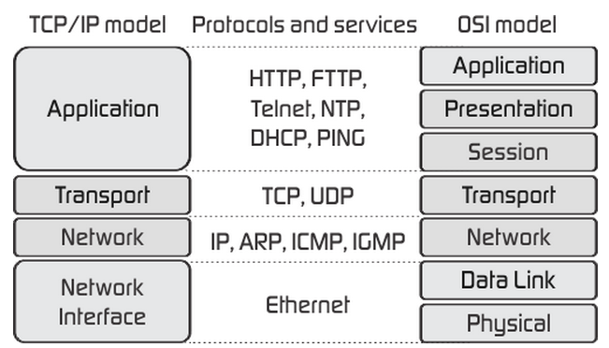
Fig. 1. Layer Models

A. Frame Headers
Below are the frame headers for Ethernet, IPv4 and ICMP in that order. Each frame is encapsulated by the previous one.

Fig. 2. Ethernet Header Frame [3]
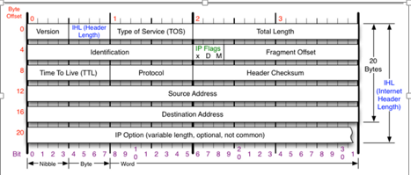
Fig. 3. IPv4 Header Frame [7]

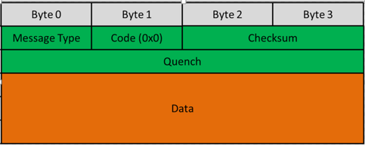
Fig. 4. ICMP Header Frame [7]

IV. ANALYZING LAN TRAFFIC
The first step in mapping the Internet is to analyze traffic on my own local area network. In Fig. 5, I pinged my laptop from my desktop which are both on the same LAN. My IP address is 192.168.1.5 and the laptop’s IP address is 192.168.1.7. The default amount of 4 packets was sent out and received with an average time of 3ms and 0% packet loss. I captured these packets in Wireshark for a closer analysis. Below is a list of packets captured by Wireshark (Fig. 6). It mainly contains ICMP and ARP protocols.

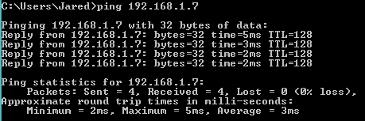
Fig. 5. LAN Ping

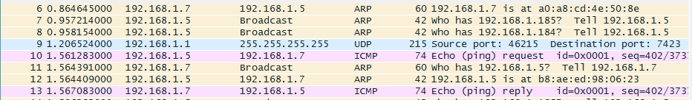
Fig. 6. Wireshark Packets

A. ARP
ARP stands for Address Resolution Protocol and it associates an IP address (Layer 3: Network Layer) to a MAC address (Layer 2: Data Link). This protocol is attempting to retrieve my laptop’s MAC address based on the IP it was given (192.168.1.7) [4].

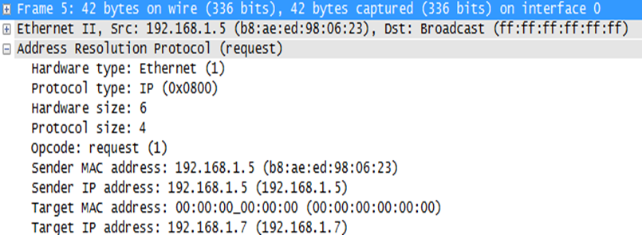
Fig. 7. Wireshark ARP Packet Frame

B. ICMP
The Ipv4 header is encapsulated in an Ethernet II frame and the ICMP data is encapsulated inside an Ipv4 packet. Taking a closer look at the ICMP request (Fig. 8) and reply packets (Fig. 9), we can see the data in the type and code fields to figure out what these packets are doing. We have also retrieved the laptop’s MAC address, as well as the pertinent ICMP information. In the reply packet info, there is an added “response time” field of 5.8ms, which corresponds to the time listed in my ping for the first packet.

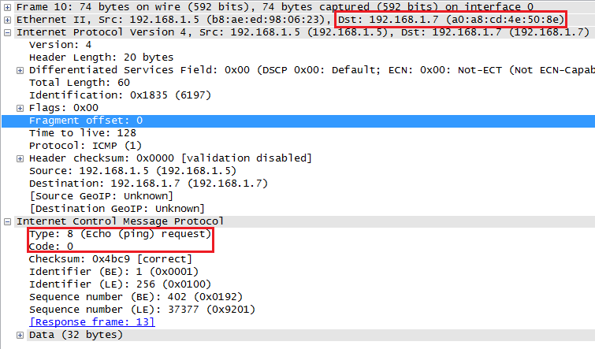
Fig. 8. ICMP Packet Request

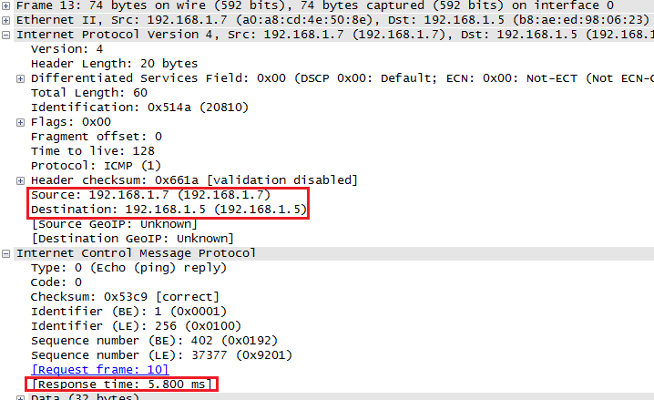
Fig. 9. ICMP Packet Reply

C. Remote ICMP
Now that we have analyzed traffic on the LAN, it is time to start analyzing traffic on remote networks. I attempted to ping www.att.com (Fig. 10). The average round trip packet time is 11ms. It is larger than the previous ping, since I’m attempting to communicate outside my LAN. The actual destination MAC address is not shown in Wireshark. My computer must use the MAC of the default gateway (my router), which routes the data based on the destination IP address. Since MAC is a layer 2 (link layer) protocol and ICMP and IP are layer 3 (network layer) protocols, I am unable to see the destination MAC address outside of my subnet.

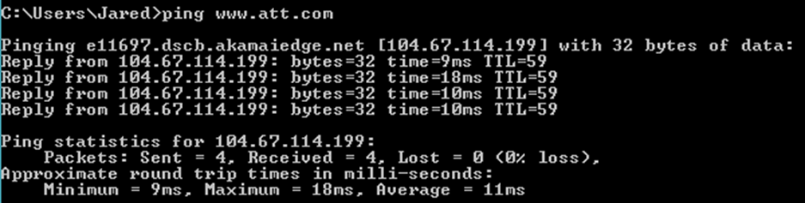
Fig. 10. www.att.com ping

Fig. 11. Default Gateway MAC

There are certain steps that must occur in order to communicate to a device on a remote network. First, my computer creates an IP packet addressed to the destination IP. Then it receives the MAC address of my default gateway (router) through an ARP request. My router receives the IP packet in a data link frame and sends the data up to the network layer. The router consults its routing table to find a path to the destination IP and gets the next hop’s IP address. Then my router sends an ARP request to get next hop’s MAC address. Consecutive routers will repeat this process until the packet reaches the destination’s subnet. The IP packet, encapsulated into a data link frame, is sent to the destination MAC address. The destination computer sends the packet back up to the network layer and data from the packet is sent up to the transport layer. Data finally reaches application layer on the destination computer to be used in whatever applications need it. [4]
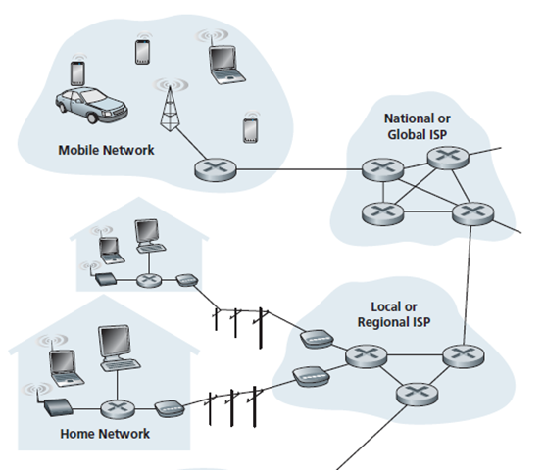
Fig. 12. Network Diagram [2]

V. MAPPING THE INTERNET
A. Tiered ISPs
There are 3 tiers of Internet Service Providers (ISPs) that connect to various hosts and networks. Tier 1 ISPs are directly connected to the Internet backbone and they can reach every other network without purchasing an IP transit. Tier 2 ISPs peer with some networks but must purchase IP transits to reach a portion of the internet. And tier 3 ISPs only purchase transits in order to reach a portion of the Internet. Tier 1 ISPs connect to each other and then branch off to provide access to Tier 2 and Tier 3 ISPs.

B. Traceroute
Traceroute allows us to see the route that the packets took to reach the destination host. It also shows a list of routers it traversed through along the path and the delay through each of them. This tool is useful for network troubleshooting and to gain insight on how networks connect together. The traceroute command for a Windows operating system is tracert.

C. First Trace: afrinic.net
Afrinic.net is the Internet Numbers Registry for Africa. I pinged www.afrinic.net and sent 4 packets with 0% loss in an average time of 328ms (Fig. 13). The delay for this ping is even longer than the previous pings because I am pinging a foreign domain. I began capturing with Wireshark with the filter “host www.afrinic.net” to only see the packets sent to and received from them. I ran a traceroute (Fig. 14) to see the path that it takes to communicate with the destination.

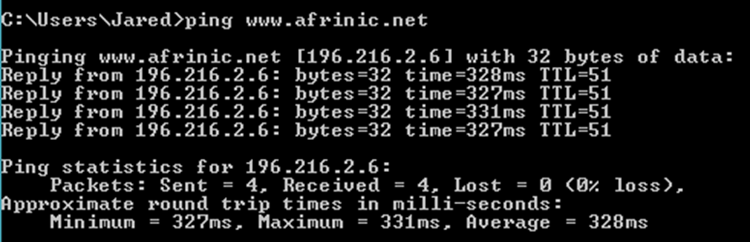
Fig. 13. www.afrinic.net ping

- Hop 1 shows me communicating with my default gateway.
- Hop 2 shows my router routing me to my ISP’s Point of Presence (POP) router at the network edge.
- Using TCPIPUTILS (http://www.tcpiputils.com), the location is determined to be in North Carolina.
- Hops 3, 4: The packets travel along my ISP’s (Cox Communications) network for two hops, eventually routing back to another router in Las Vegas.
- Hop 5: The packet travels to another ISP called Level 3 that has an edge router for Las Vegas. Level 3 is considered to be a Tier 1 ISP.
- Hops 6-8: The packets travel along Level 3’s network until it get to an edge router in London.
- Hop 9: The packet travels to another ISP called Internet Solutions in South Africa.
- Hop 13: Packet arrives at remote server.

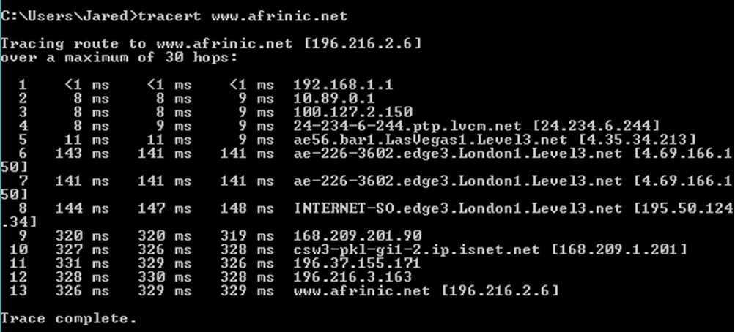
Fig. 14. Afrinic.net traceroute

D. Tier 1 ISP Level 3
Level3 from the previous traceroute is an example of a tier 1 ISP. As would be expected from a tier 1 ISP, they have an extensive global network and connect to other lower tier ISPs, such as Cox Communications. Below is a map of their global network.
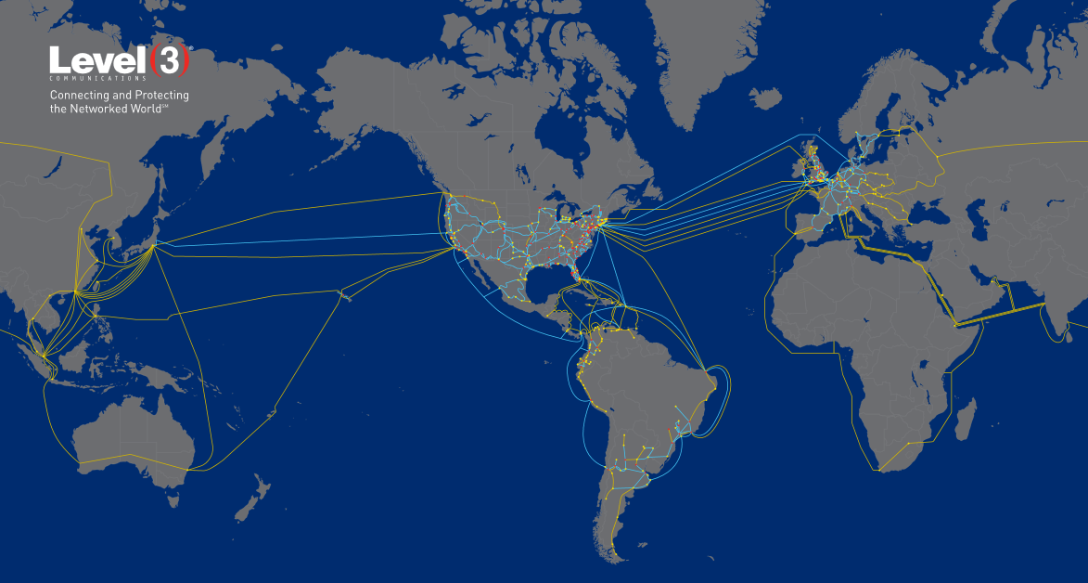
Fig. 15. Level3 Network

E. Second Trace: NTT Communications
Next I attempted to ping another tier 1 ISP, NTT Communications in Japan, but request timed out with a 100% packet loss. So I ran a traceroute to analyze and troubleshoot the problem. Before timing out at hop 15, it arrives at a router that belongs to NTT Communications in Tokyo Japan very close to the destination. I suspect that for security reasons, they may have disabled the ability to ping the server directly and stop the ping request at their default gateway.

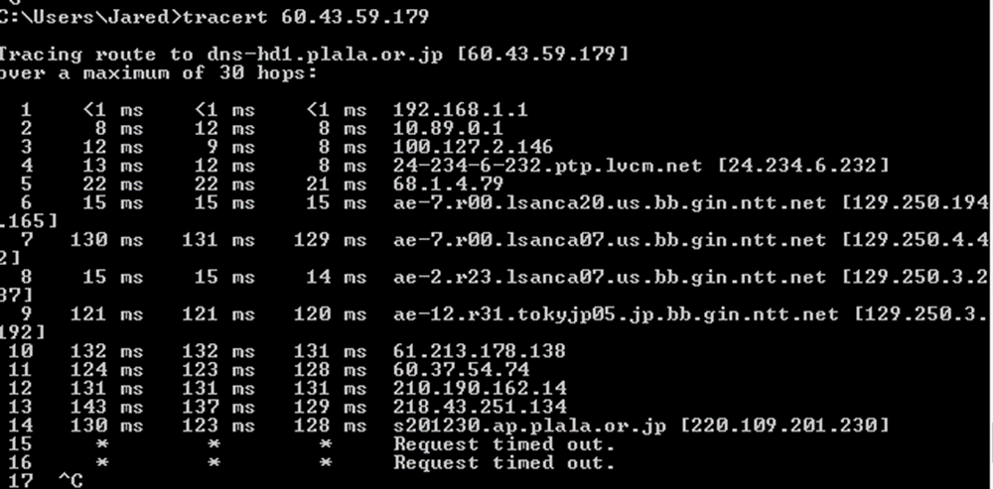
Fig. 16. NTT Communications traceroute

VI. WIRESHARK PROTOCOL ANALYSIS
A. TCP

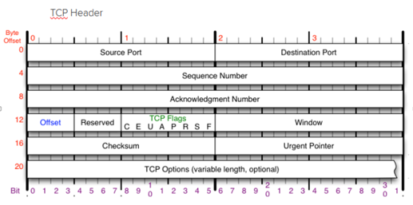
Fig. 17. TCP Header [7]

The following packets illustrate the TCP handshake process (Layer 4: Transport). TCP information is encapsulated in the IPv4 header. TCP headers do not specify the IP addresses since it is already handled by the IP header in the network layer at this point. The source port for this packet is port 80, which signifies an http protocol. My computer sends a SYN signal in an attempt to initiate communication. The destination responds with a SYN, ACK signal to acknowledge that it received the signal. Then a final packet sends an ACK signal to ensure that the previous acknowledgment was not lost. A Wireshark filter of the form, tcp.flags.syn == 1, can be used to search for a specific type of TCP packet. In a similar fashion to initiating communication, my computer also sends signals to terminate a session. These signals are FIN, FIN-WAIT, and FIN-ACK. The source sends FIN to tell the destination that there is no more data. Destination sends a FIN-WAIT signal back and the source sends a FIN-ACK to terminate.

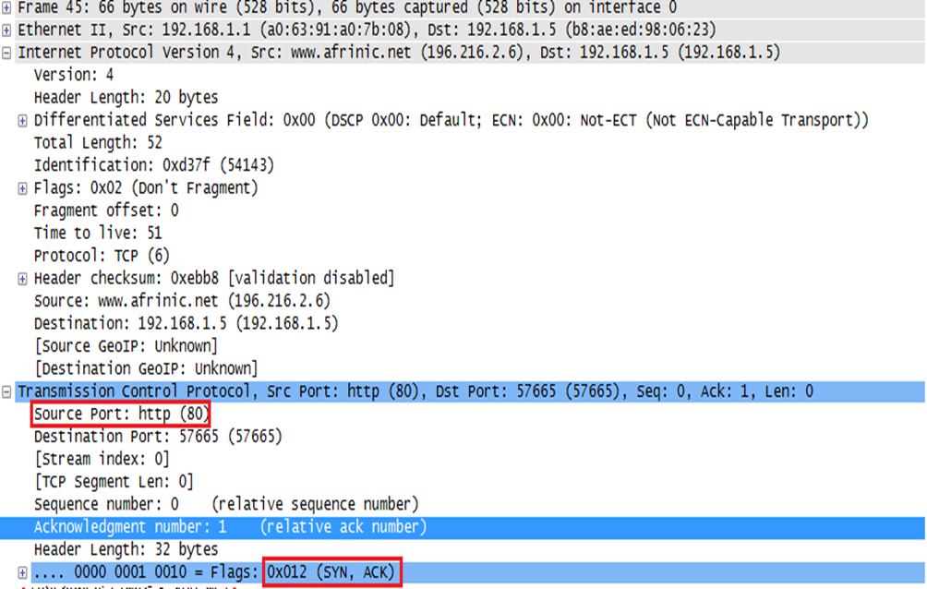
Fig. 18. TCP Packet

B. HTTP
The HTTP protocol is part of the application layer and is encapsulated in the TCP header. There are many status codes that signify the operation of an http packet. My computer sends an http request to destination (GET) with a status code of 0. Then the destination sends back an OK signal with the status code 200, if there are no problems. Wireshark filters of the form, http.response.code==200, can be used to search for specific types of HTTP packets.

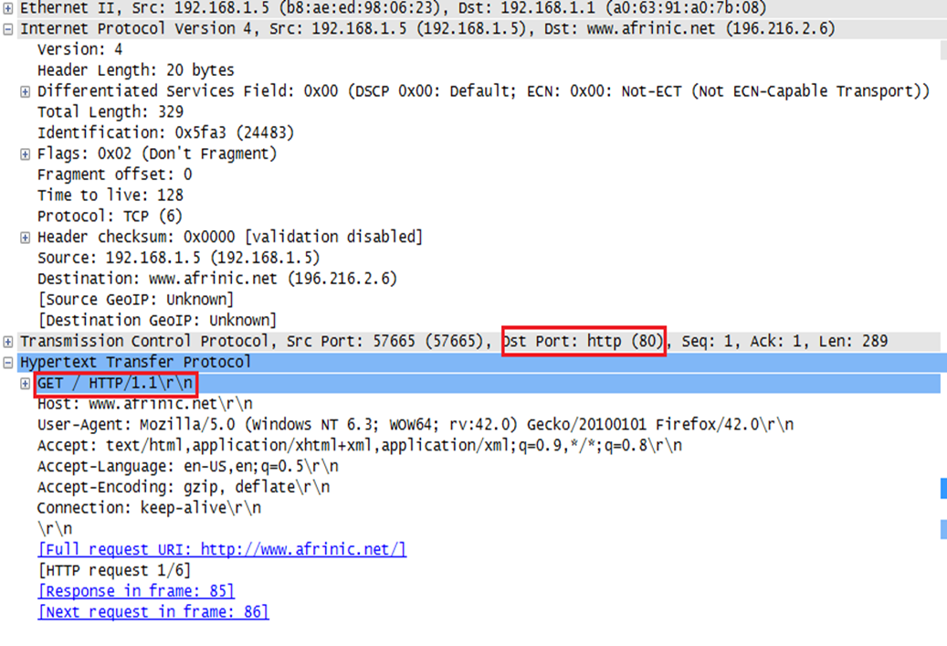
Fig. 19. HTTP Packet

C. UDP
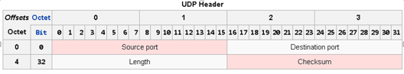
Fig. 20. UDP Header [3]

UDP is a connectionless protocol and it requires little overhead. Just like the TCP protocol it is encapsulated in an IP packet. IP addresses and sequences are not specified because they are already handled by the IP packet on the network layer

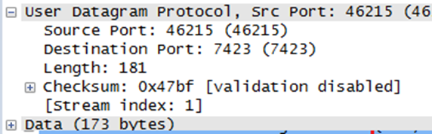

Fig. 21. UDP Packet

VII. CONCLUSIONS
With Wireshark and the traceroute tool, it was possible to map out the Internet in relation to my home network. The three traces executed in this analysis was able to generate and map out traffic nationally, as well as globally. We could see packets being handed off between the networks of major ISPs as well as the transition between the different tiers of ISPs when communicating to a foreign domain. Because of this, we were able to gather a comprehensive mapping of the Internet with just three traces. We were then able to also analyze the structure of network operation through the Internet layers using Wireshark’s packet analyzer. Wireshark output is organized to convey on which layers various protocols are executed and its relation to the layer hierarchy. In Fig. 24, I used the NMAP software to generate my final mapping of the Internet based off of the aforementioned three traces.

TABLE I. Trace Comparison

Domain | Avg. Delay | # of Hops | Packet Loss
www.att.com | 3ms | 6 | 0%
www.afrinic.net | 11ms | 13 | 0%
NTT Comm. | 328ms | 15 | 100%

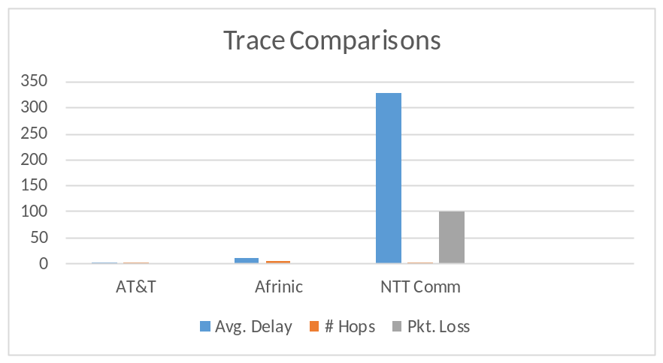
Fig. 22. Trace Comparison

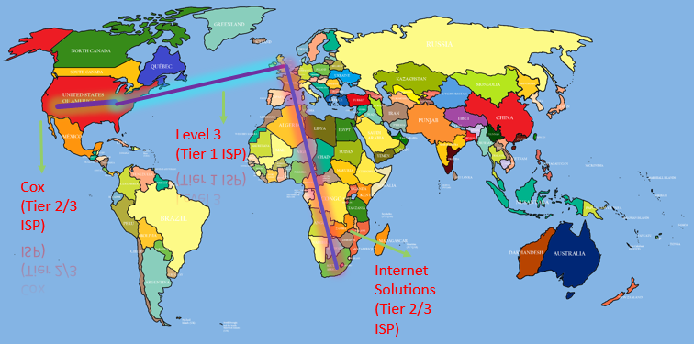
Fig. 23. Afrinic trace

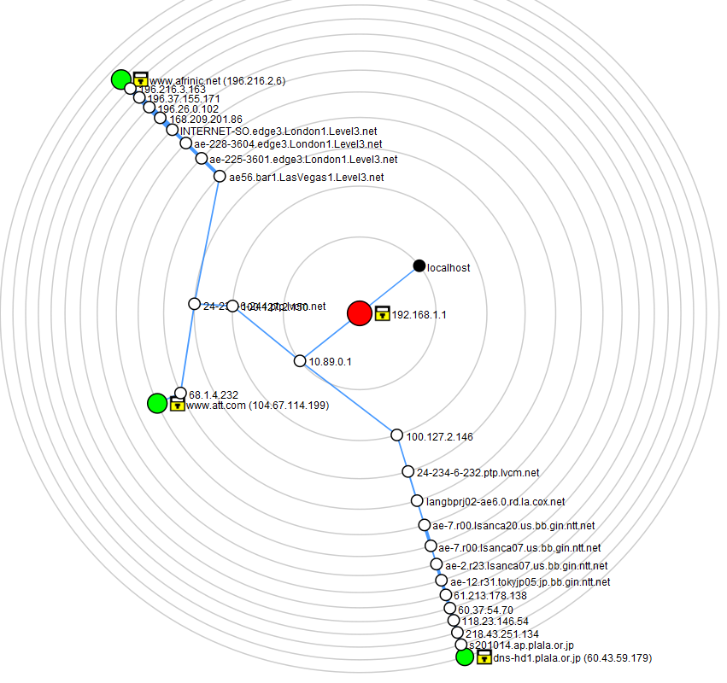
Fig. 24. Network Topology

VIII. REFERENCES
- A. S. Tenenbaum, Computer networks, 4d. ed. New Delhi: Prentice Hall of India Pvt. Ltd., 2009.
- J. F. Kurose and K. W. Ross, Computer networking: a top-down approach, 4th ed. Boston: Pearson/Addison Wesley, 2008.
- “Ethernet,” - The Wireshark Wiki. [Online]. Available at: https://wiki.wireshark.org/ethernet. [Accessed: Aug-2015].
- “How ARP works,” Tildefrugal. [Online]. Available at: http://www.tildefrugal.net/tech/arp/. [Accessed: Aug-2015].
- “The structure of the Internet | Affordable Web Hosting Calgary Edmonton Toronto business Canada,” Affordable Web Hosting Calgary Edmonton Toronto business Canada. [Online]. Available at: http://computerengineering.ca/about-the-internet/the-structure-of-the-internet/. [Accessed: Aug-2015].
- “Wikipedia,” Wikipedia. [Online]. Available at: https://en.wikipedia.org/wiki/internet. [Accessed: Aug-2015].
- “News,” Nmap: the Network Mapper. [Online]. Available at: https://nmap.org/. [Accessed: Aug-2015].

